[1]

Automatic Street Light Controlling On Natural Light Intensity

(December 2019)

Alimul Hasan Jami, A. F. M. Mejbahul Haq, Seyam Rabbi and Nefaur Rahman Labib

***Abstract*—In our microprocessor project, we selected “Automatic Street Light Controlling System on Natural Light Intensity”. The aim of this project is to design and execute an energy efficient street light system. The present system work like that the lights will be switch on before sunset and off on the next morning. Which is not energy efficient because the light requirement is not same all that long time. According to our system lights will be on/off or intensity will increase/decrease based on the need according to natural light. In this system, we will take value of LDR(Light Detecting Resonance), that will give the value of natural light intensity. After processing the data, Arduino will control whether the output street lights will be on/off and the intensity will also be controlled. Rather than keep the street light on. The intensity of the lights will be increased only when its necessary. We expect that the system will help to decrease energy-wastage.**

***Index Terms*—Arduino, Automation, Light Intensity, Street Light**

# INTRODUCTION

I

In Bangladesh, every year a huge amount of electricity is being wasted because of not having any control over street lights. Because of the negligence of switching street lights off and on, a great amount of energy is being wasted which could have been used to meet the demand of thousands of rural households. According to a recent survey by the government’s Power Cell, street lamps should be turned on just before sunset and turned off right after sunrise every day. But in reality, the staff turn these lamps on at least half an hour before sunset and leave them on even two hours after sunrise. Energy efficient technology and design mechanism can decrease cost of the street lighting drastically. Besides manually controlling and monitoring needs manpower which means more costly. In our solution, we are setting up a system to control street lights intensity based on natural light. If the system can be implemented in street lights, huge amount of electricity can be saved.

# Related Work

There are several attempts to control the road lighting for saving the energy and to reduce the pollution. In [1,2] a road lighting intelligent control system is proposed. The system is based on wireless network control that can implement real-time monitoring for road lighting. The proposed system uses the Zigbee wireless networks and GPRS standard to monitor the status of the lamps. The goal is to allow a central monitoring of the status of road light terminals that are equipped with wireless controller and electronic ballasts to be able to remotely switch on or off the terminals. Furthermore, the system can be programmed to switch all the terminals to half-power state at specific time to save the energy. There are several limitations of this system. First, its complexity and cost: each node or terminal must have microprocessor, controller, and wireless interface. This can increase the cost too much and hence hinder the wide-scale deployment of the system. Second, it is using a completely new network rather than using the existing 2 network for the road lighting control and management. Third, the system is not automatic. The system will be programmed to dime the terminals at specific time. The system does not take into account the presence of vehicles or not. Thus, it cannot achieve the maximum power-saving. Another proposal that is similar to the system proposed in [1,2] is given in [3]. Similar control system that uses GPRS is given in [4]. In order to monitoring and control each street lighting, the wireless sensor network (WSN) was developed in [5] The system consists of sensor node, remote terminal unit (RTU) and control center. The sensor nodes were installed at each lighting pole and make up a network with RTUs. The sensor senses the status of the lamp and the light intensity. Using the Power Line Communication (PLC) [5-7], the status and the control signals can be sent from the RTU and the control center or vice versa. Another related work that uses the WSN is given in [8]. Another system for controlling the road lighting is proposed in [9] where the streets is divided into regions. By using vehicle-detection loops in each region, the number of vehicles entering that region can be obtained. Thus, using a dedicated network and control system, any region can be switched on or off depending on whether there are vehicles detected in that region or not. They calculated a figure of 23.7% power saving if the system is used. Another energy-saving direction, with no lighting con-

trol, is to change the old lighting system with more sophisticated and energy saving equipments. For example, in [14] by replacing the old system in Thailand by a new high pressure sodium (HPS) road lighting, they saved up to 25% - 30% of the energy. Similar related work to this

trend is by using the LEDs [10] (Light Emitting Diodes) lamps that can consume only the quarter of the HPS lamps and give almost the equivalent luminous efficacy.

# Components

1. Microcontroller: Arduino

Arduino is an open-source hardware and software company, project and user community that designs and manufactures single-board microcontrollers and microcontroller kits for building digital devices. Its products are licensed under the GNU Lesser General Public License (LGPL) or the GNU General Public License (GPL),[1] permitting the manufacture of Arduino boards and software distribution by anyone. Arduino boards are available commercially in preassembled form or as do-it-yourself (DIY) kits.

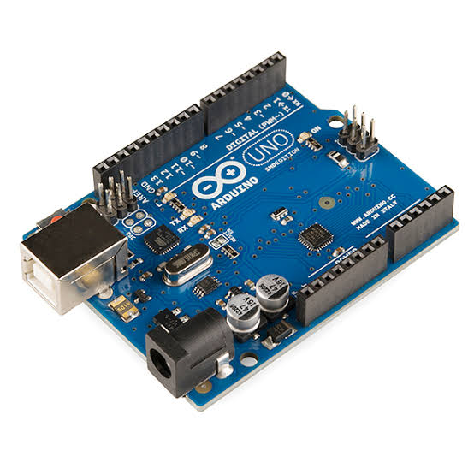

1. LDR Sensor

An LDR is a component that has a (variable) resistance that changes with the light intensity that falls upon it. This allows them to be used in light sensing circuits. Light Dependent Resistors (LDR) are also called photoresistors. They are made of high resistance semiconductor material. When light hits the device, the photons give electrons energy. This makes them jump into the conductive band and thereby conduct electricity.

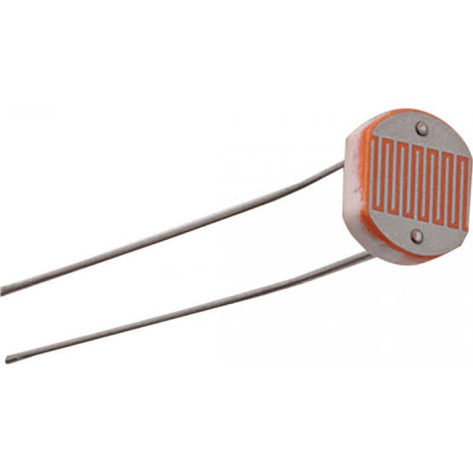

1. LED Light

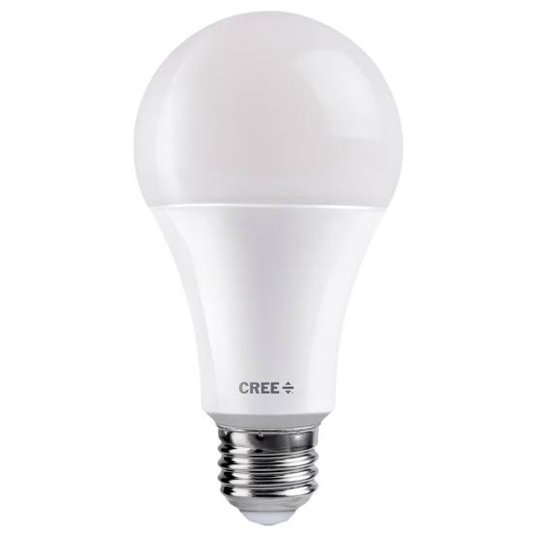

1. Capacitor

A capacitor is made up of two metallic plates. With a dielectric material in between the plates. By using a capacitor, the capacitor can supply power for the microcontroller in the split second that the voltage drops so that the microcontroller doesn’t restart. This way it will filter out the “noise” on the power line.

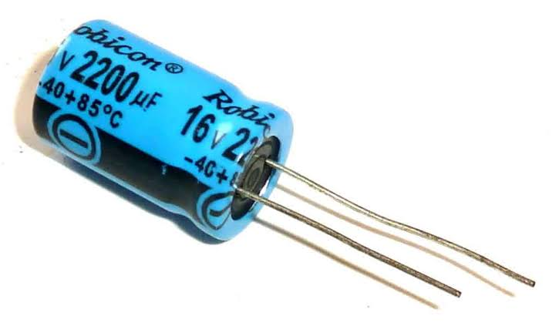

1. Resistor (1k,10k)

A resistor is a passive two-terminal electrical component that implements electrical resistance as a circuit element. In electronic circuits, resistors are used to reduce current flow, adjust signal levels, to divide voltages, bias active elements, and terminate transmission lines, among other uses.

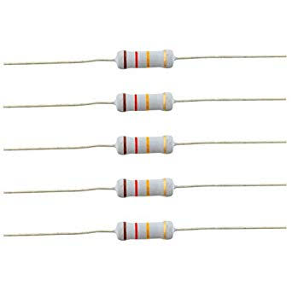

1. Project Board

The Project Board has the following duties:

* To be accountable for the success or failure of the project.
* To provide unified direction to the project and Project Manager.
* To provide the resources and authorize the funds for the project.
* To provide visible and sustained support for the Project Manager.
* To ensure effective communication within the project team and with external stakeholders.



1. Wire

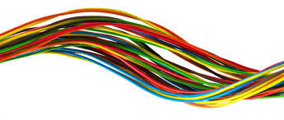

1. Relay

One can control high voltage electronic devices using relays. A relay is actually a switch which is electrically operated by an electromagnet. The electromagnet is activated with a low voltage, for example 5 volts from a microcontroller and it pulls a contact to make or break a high voltage circuit.

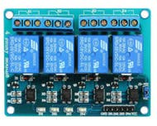

# System Architecture

This project uses the HL-52S 2 channel relay module, which has 2 relays with rating of 10A @ 250 and 125 V AC and 10A @ 30 and 28 V DC. The high voltage output connector has 3 pins, the middle one is the common pin and from the markings one of the two other pins is for normally open connection and the other one for normally closed connection. On the other side of the module we have 2 sets of pins. The first one has 6 pins, a Ground and a VCC pin for powering the module and 4 input pins In1, ln2, ln3 and In4. The second set of pins has 3 pins with a jumper between the JDVcc and the Vcc pin. With a configuration like this the electromagnet of the relay is directly powered from the Arduino Board and if something goes wrong with the relay the micro controller could get damaged.

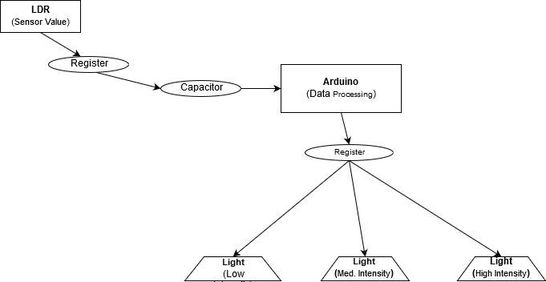

# Implementation

We used Arduino language which is mainly C and C++. The code is given below-

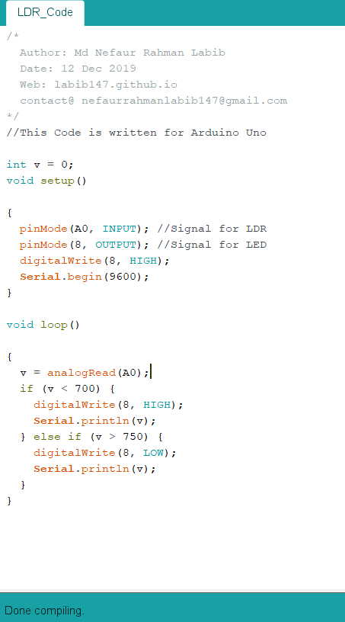

Here, we are using A0 pin value as input and generating output through 3 number pin. After mapping the value to analog[0 to 255 (2^8-1=255)] the output is given according to the condition.

# Performance Evaluation

Increasing the efficiency and automation of street light control system is an important issue. The main advantages of this system consist in substantially reducing the costs related to energy consumption and maintenance. Circuit works properly in order to turn the street lights ON/OFF. LDR sensor and the Arduino are the two main conditions in working the circuit. The street lights has been successfully controlled by Microcontroller (Arduino). The LDR can send date to Arduino and it send out signal to LEDs. This system can be implemented in our country and the necessary equipment are available in market. So, this can be both energy and money saving project for government.

# Conclusion

This report elaborates the design and construction of automatic street light control system. We can observe and measure the huge wastage of energy. If this system can be implemented everywhere, lights would have been given its full output only when it is needed, rest of the time it can save energy. A significant amount of energy could be saved from our national grid. Finally, it can be an efficient solution.

Acknowledgment

Thanks to our honourable course instructor Dr Motaharul Islam sir.

References

1. L. Li, X. M. Chu, Y. Wu and Q. Wu, “The Development of Road Lighting Intelligent Control System Based on Wireless Network Control,” Proceedings of International Conference on Electronic Computer Technology, Macau, 20-22 February 2009, pp. 313-357.
2. Y. Wu, X. M. Chu, Q. Wu and L. Li, “The Road Lighting Control Technology Research Baseon Ubiquitous Net-work,” Proceedings of the 5th International Conferenceon Wireless Communications, Networking and Mobile Computing, Beijing, 24-26 September 2009, pp. 1-4.
3. J. D. Lee, K. Y. Nam, S. H. Jeong, S. B. Choi, H. S. Ryoo and D. Kim, “Development of Zigbee Based Street Light Control System,” Power Systems Conference and Exposition, Atlanta, 29 October-1 November 2006, pp. 2236- 2240.
4. Y. Wu, C. H. Shi, X. H. Zhang and W. Yang, “Design of New Intelligent Street Light Control System,” 8th IEEE International Conference on Control and Automation(ICCA), Xiamen, 9-11 June 2010, pp. 1423-1427.
5. C. G. Jing, L. C. Ren and D. Y. Gu, “Geographical Routing for WSN of Street Lighting Monitoring and Control System,” International Conference on Computer Design and Applications (ICCDA), Vol. 3, 2010, pp. 235-238.
6. E. H. T. Ei-Shirbeeny and M. E. Bakka, “Experimental Pilot Project for Automating Street Lighting System in Abu Dhabi Using Power Line Communications,” Proceedings of the 10th IEEE International Conference on Electronics, Circuits and Systems, Vol. 2, 2003, pp. 743-746.
7. A. del Rio Vazquez, J. Doval-Gandoy, S. Perez Perez and J. Dios Vidal, “Characterization of a Street Lighting Power Line When Used as a Communications Channel in the 115 kHz Band,” IEEE International Symposium on Industrial Electronics, Vigo, 4-6 June 2007, pp. 3062- 3065.
8. M. Mendalka, M. Gadaj, L. Kulas and K. Nyka, “WSN for Intelligent Street Lighting System,” 2nd International Conference on Information Technology (ICIT), Gdansk, 28-30 June 2010, pp. 99-100.
9. C. Y. Liu, Q. G. Wang and F. Y. Zhang, “Design and Development of City Street-Lighting Energy-Saving System,” 2nd Pacific-Asia Conference on Circuits, Communications and System (PACCS), Vol. 1, 2010, pp. 178- 182.
10. K. Hyodhyad and P. Srikaew, “Result of Road Lighting Energy Saving Project Implementation through the Use of Public Private Partnership Scheme,” Proceedings of the International Conference on Energy and Sustainable Development: Issues and Strategies (ESD), Chiang Mai, 2-4 June 2010, pp. 1-4.
11. F. S. Li, D. H. Chen, X. J. Song and Y. M. Chen, “LEDs: A Promising Energy-Saving Light Source for Road Lighting,” Asia-Pacific Power and Energy Engineering Conference, Wuhan, 27-31 March 2009, pp. 1-3. doi:10.1109/APPEEC.2009.4918201

1.